**To Understand- Co2 Emission Per Capita, Co2 Emission By International Factors, Emission Rate Over Years**

**Co2 Emission Per Capita:**

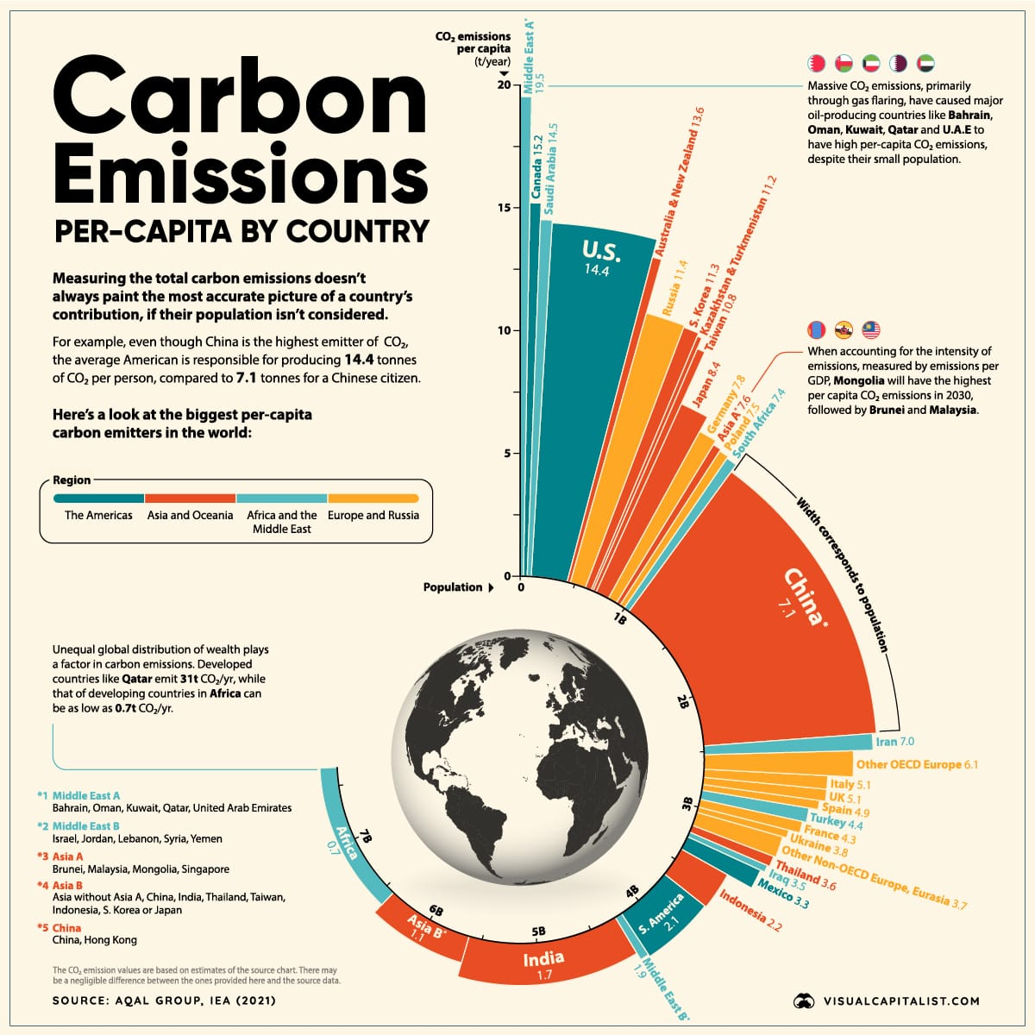

**Co2 Emission By International Factors:**

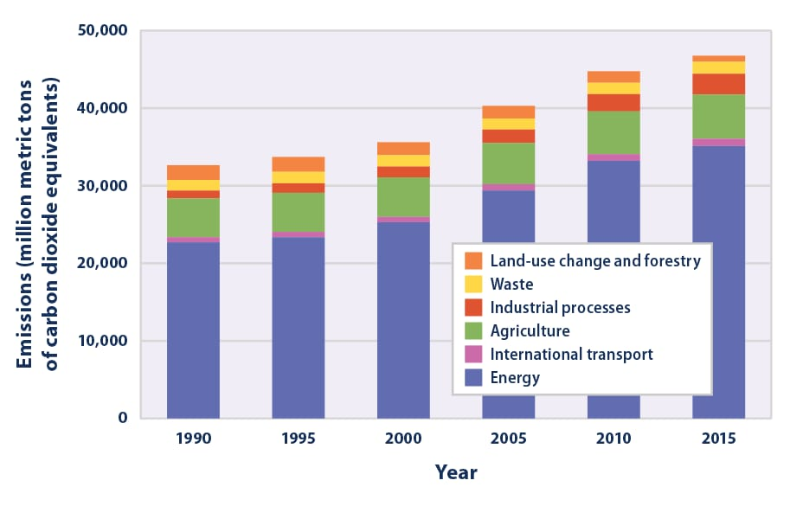

**Emission Rate Over Years:**

